Assignment 10.4:

1. Write a pig script find the average age of male and female persons died in the titanic tragedy

Pig Script:

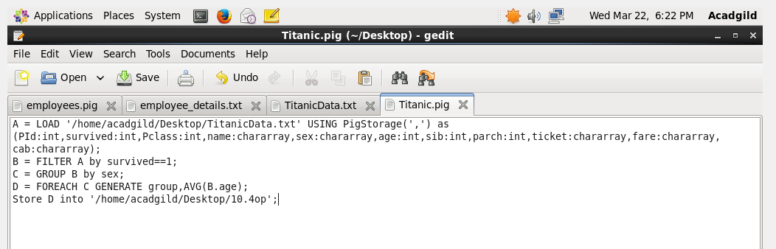

Output:

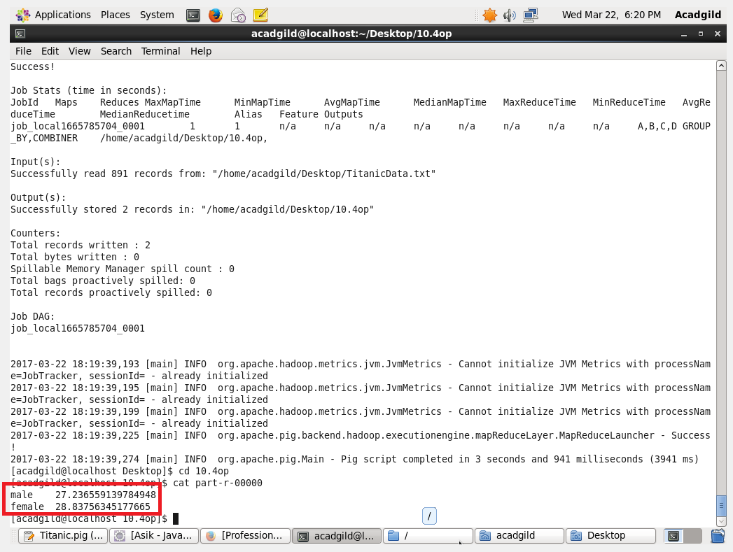

1. Write a pig script to find the number of people died and survived in each class:

Pig Script:

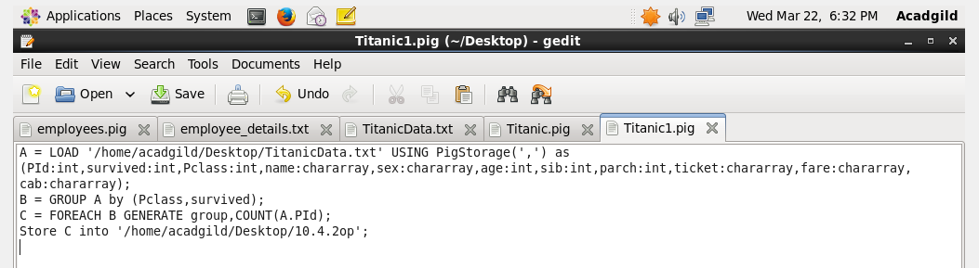

Output:

